PRESS RELEASE

................................................................................................

**Nordic Pet Food Seminar**

FEDIAF presents work to European Pet Food Industry in Prague

At the Nordic Pet Food Seminar in Prague, the Deputy Secretary General of the European Pet Food Federation (FEDIAF) spoke about the three pillars of self- and co-regulation underpinning the industry and their role in harmonizing the enforcement of EU regulations to ensure safe and nutritious pet food.

Brussels/Prague, October 2018 – There are more than 50 EU laws that apply to pet food – these cover all aspects of the pet food production cycle from the ingredients that can be used to the information which must be on the pet food label. “FEDIAF continuously cooperates with the EU and national authorities to keep these harmonised and up-to-date based on the latest science and regulatory developments”, Julien Taïeb said during his speech at the 4th Nordic Pet Food Seminar in Prague.

This important pet food event gathers pet food manufacturers, ingredient suppliers and researchers of universities and institutes from across Europe. Taïeb explained: “Our association has been building on its excellent track record in terms of safety, nutrition and reputation through three pillars of self- and co-regulation: the Nutritional Guidelines, the Good Manufacturing Practice Guide and the Labelling Code.”

Harmonised approach to regulations

As the first pillar of self- and co-regulation, the 2018 version of the Nutritional Guidelines for Cat and Dog Food was presented to representatives from the pet food industry. The document serves as a practical guide for cat and dog food manufacturers and sets nutritional requirements benchmarked against science for use by the whole industry. “Being updated annually with the help of a Scientific Advisory Board composed of European pet nutritionists from universities, our Nutritional Guidelines are the reference document for producing complete pet food”, Taïeb said.

The FEDIAF Good Manufacturing Practice Guide is the second pillar. This guide summarises the requirements any pet food manufacturer must fulfil to put in place a robust pet food safety management system in order to produce safe pet food.

The third pillar is the FEDIAF Labelling Code that covers information on product use, control and enforcement, retail and marketing and provides clear rules and examples on product claims. “EU labelling regulations cannot specify every detail that would cover all commercial situations; the Code thus provides practical guidance on how labelling requirements should be applied and implemented in order to ensure a level playing field for manufacturers or pet food companies”, Taïeb explained.

Free download

The three self- and co-regulation documents mentioned above can be downloaded for free on the FEDIAF website:

[www.fediaf.org/self-regulation/nutrition.html](http://www.fediaf.org/self-regulation/nutrition.html)

[www.fediaf.org/self-regulation/labelling.html](http://www.fediaf.org/self-regulation/labelling.html)

www.fediaf.org/self-regulation/safety.html

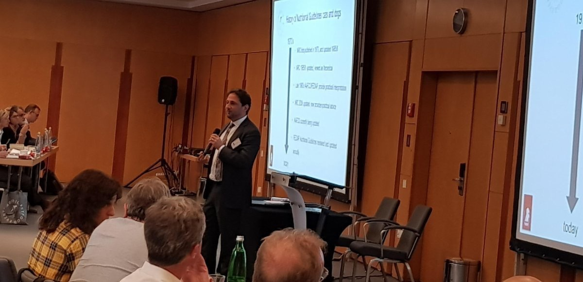

Julien Taïeb, Deputy Secretary General of FEDIAF, presented FEDIAF’s work during the 4th Nordic Pet Food Seminar in Prague.

**\*\*\***

***FEDIAF*** *represents the European pet food industry with around 200 production sites. Serving as an umbrella organization of national pet food industry associations, FEDIAF’s mission is to be the credible and responsible voice of the European pet food industry collaborating with authorities, regulators and academics for achieving favourable conditions for the supply of safe, nutritious and palatable products to pets and their owners. Based in Brussels, FEDIAF is fully committed to promoting responsible pet ownership, to the wellbeing of pet animals, to their important social role and to the respect of sustainable development.* [www.fediaf.org](http://www.fediaf.org)

*Contact: Thomas Meyer, Secretary General, + 32 (2) 536 05 20 –* [fediaf@fediaf.org](mailto:fediaf@fediaf.org)