PRESS RELEASE
................................................................................................

FEDIAF presents new Nutritional Guidelines at Vet Congress

FEDIAF, the European Pet Food Industry Federation, has just released the 2018 edition of its scientifically reviewed Nutritional Guidelines for Cat and Dog Food. The updated version was presented earlier this month at the 22nd European Society of Veterinary and Comparative Nutrition (ESVCN) Congress in Munich.

Brussels, September 2018 – The FEDIAF Nutritional Guidelines for Cat and Dog Food have become “a science-based tool box”, said Dr Thomas Brenten, Chair of the FEDIAF Nutrition and Analytical Science Working Group. Earlier this month he presented the freshly revised guidelines to an audience of around 100 veterinarians, scientists, nutrition experts and students at the 22nd European Society of Veterinary and Comparative Nutrition (ESVCN) Congress in Munich.

“One of FEDIAF’s main objectives is to safeguard the wellbeing of pets by providing well balanced and nutritionally sound pet food through its member companies”, Dr Brenten explained. “That is why FEDIAF has taken up the task of regularly adapting the recommendations for nutrient levels in pet food in close cooperation with independent scientists. This enables the pet food industry to adjust the nutritional quality of complete diets for dogs and cats based on state-of-the-art scientific knowledge.”

To achieve that goal, FEDIAF’s experts work together with a Scientific Advisory Board that includes independent and renowned scientists from European countries. The Scientific Advisory Board ensures the scientific standards of the recommended nutrient levels are maintained and advises FEDIAF so that the latest research results are transferred into the guidelines and current feeding practice.

The “Nutritional Guidelines for Complete and Complementary Pet Food for Cats and Dogs” can be downloaded for free at the FEDIAF website: www.fediaf.org/self-regulation/nutrition.html or by scanning the QR code below.

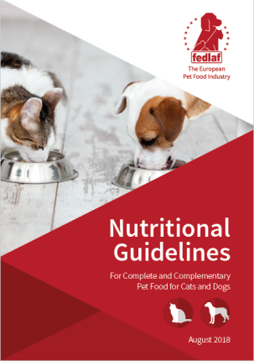

The “Nutritional Guidelines for Complete and Complementary Pet Food for Cats and Dogs” can be downloaded for free at the FEDIAF website: www.fediaf.org/self-regulation/nutrition.html

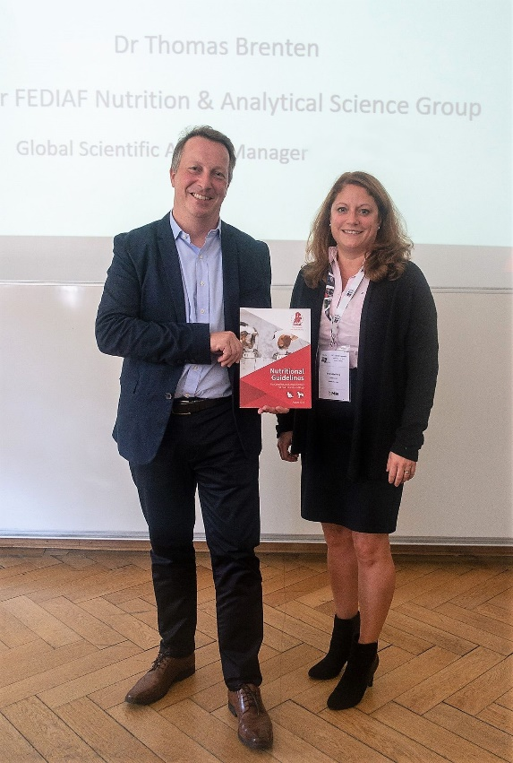

Members of the Nutrition and Analytical Science Working Group Dr Thomas Brenten and Dr Petra Hellweg

***
FEDIAF represents the European pet food industry with around 200 production sites. Serving as an umbrella organization of national pet food industry associations, FEDIAF’s mission is to be the credible and responsible voice of the European pet food industry collaborating with authorities, regulators and academics for achieving favorable conditions for the supply of safe, nutritious and palatable products to pets and their owners. Based in Brussels, FEDIAF is fully committed to promoting responsible pet ownership, to the wellbeing of pet animals, to their important social role and to the respect of sustainable development. www.fediaf.org
Contact: Thomas Meyer, Secretary General, + 32 (2) 536 05 20 – fediaf@fediaf.org

